**Assignment**

Couse: Operating Systems Design(146043-31001), 2021

Name: Chang wan Woo

Programming Assignment NUMBER: Implementation assignment #4

Due DATE: 2021/06/01

**Program environment**

Window 10, Interllij, java version "1.8.0_291",

Java(TM) SE Runtime Environment (build 1.8.0_291-b10)

**How to start?**

**1.Unzip file into eclipse workspace.**

**2. Import ( File > import > existing Projects into workspace**

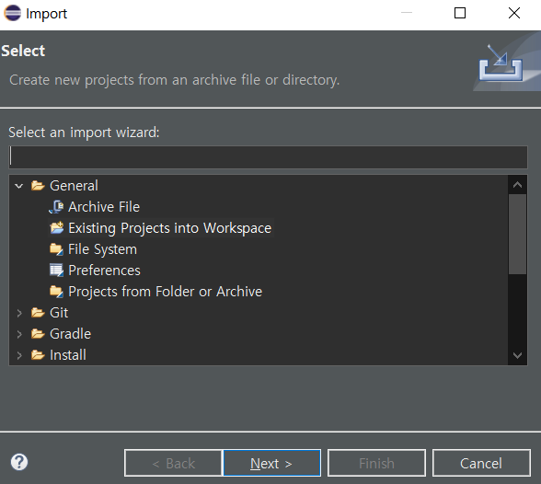

**3. Browse > implementation_assignment4(it is located in your workspace)**

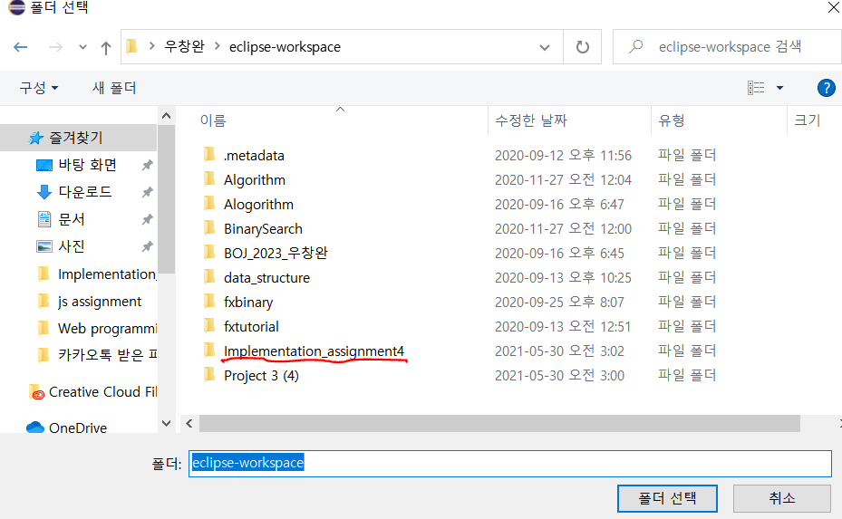

By these steps you can show my program an run my program as well. There are three algorithms to start. If you enter 0, algorithm without page replacement is proceeded. If you enter 1, virtual memory with FIFO algorithm is proceeded and lastly if you enter 2, virtual memory with LRU algorithm is proceeded.

Finally, you can see the result for TLB hit rate and number of page fault on the command line.

**Problem statement**:

In memory management, we use logical memory to separate physical memory to enhance performance. So, in this project I mapped logical memory and physical memory with page replace algorithms: FIFO and LRU. Also, we can see number of page fault and TLB hit rate for each algorithm.

**Software design:**

To make LRU and FIFO algorithms, I used linked list and queue in this project. When program need to replace page, each algorithm selects victims and replace its page and allocate frame. In LRU algorithm, linked list operated stack. If page reference is requested, program first check TLB, and if page is in TLB, it refers TLB, otherwise it looks page table. If there is page, it refers corresponding physical memory and otherwise it allocates free frame for request.

I implemented LRU and FIFO algorithms when size is larger than 128 which is frame size for two algorithms. In this process each algorithm selects victim for replacement. When **replacement** is occurred, I print out which frame is reallocated to page.

**Implementation**

**Code explanation**

**1. If user takes input 0**

Frame size is 256, so page replacement does not occur, so it assign new frame for corresponding page_number and add frame to physical memory.

2.If user takes input 1

If user takes input 1, it executes page replacement with FIFO algorithm. FIFO algorithm selects victim if there are more than 128 inputs like as below.

Victim is selected in front of queue and rest table[victim].frameNumber=-1 and table[victim].valid=false. After reset, it updates page table, TLB and replacedPage list.

If size is less than 128, it allocate in physical memory and call FIFO_add to add in page table

**3.If user takes input 2,**

Unlikely FIFO algorithm, LRU algorithm has to update list. If page is already in list, remove corresponding value and add to the top.

The LRU_selects in front of value as a victim and likely FIFO, reset its framenumber and validation.

If frame is less than 128, it adds page_number without page replacement.

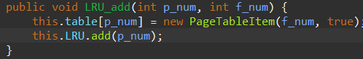

**Error handling:**

**In this program, it takes input from user. Input should be range from 0 to 2 otherwise program consider input invalid and print error message and take input again.**

**Test Description and Results**

**Test1: Input:0**

**Input:**

**Output:**

**TLB hit rate= 5.5% (55 happens)**

**Page fault rate 24.4% (244 happens)**



**We can see there is no page replacement,**

**Test 2**

**Input: 1 (page replacement with FIFO)**

**Output:**

**TLB hit rate 5.3%( 53 happen), page fault rate: 53.8% (538 happen)**

**The below image shows which page is replaced during executions.**



**We can see replacement and reference on the command line.**

**Test 3**

**Input: 3 (Page replacement with LRU algorithm)**

**Output**

**TLG hit rate: 5.7%(57 times happen) Page fault rate 53.9%(539 times happen)**

**The below image shows which page is replaced during executions.**



**Also, as same as FIFO algorithm, if frame is needed to be replacement, program prints out which frame is reallocated to page.**

[Introduction]: The program being executed must be in main memory. However, in many cases, the entire program in not necessary, so by introducing virtual memory, it has benefits from virtual memory is that programs can be larger than physical memory and abstracts main memory into large, uniform array of storage so that it can implement multi programming and increase CPU utilization. Further it requires less I/O or swapping programs.

[Process]: If there is reference page before, it refers page table and mapped to physical memory using page number and offset. Otherwise, if the bit is set to invalid, it causes trap to operating system and store its current state. Operating system check internal table to determine the reference was a valid or an invalid memory access. If it is invalid, terminate the process. If it is valid operating system schedule secondary storage operation to bring desired page into newly allocated frame. After it is completed, operating system modifies page table to indicate the page is now in memory and restore instructed instruction.

[Analyzing code]

[AddressTranslator]

**[PageTable]**

The page table constructor allocate page table array and initiates it value by -1 and false.

The get(int p_num) method is accessed by other class by sending parameter p_num(parameter number). If there is corresponding frame number, return frame number otherwise returns -1.

The add method adds page number and frame number in table

**[PageTableItem]**

The page table item stores its frame number and valid information.

**[TLB]**

[BackStore]

In the BackStore, declare its value and result type and find corresponding real data in backstore.

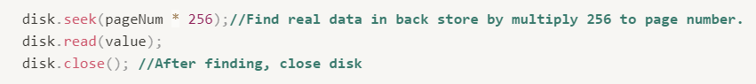

[Frame]

The addFrame method returns frame number.

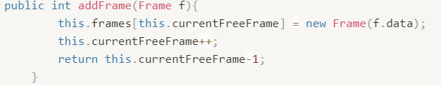

The int getValue returns corresponding value in frame.

